# **CTF Challenge: Ethical Hacking – Using ViewDNS**

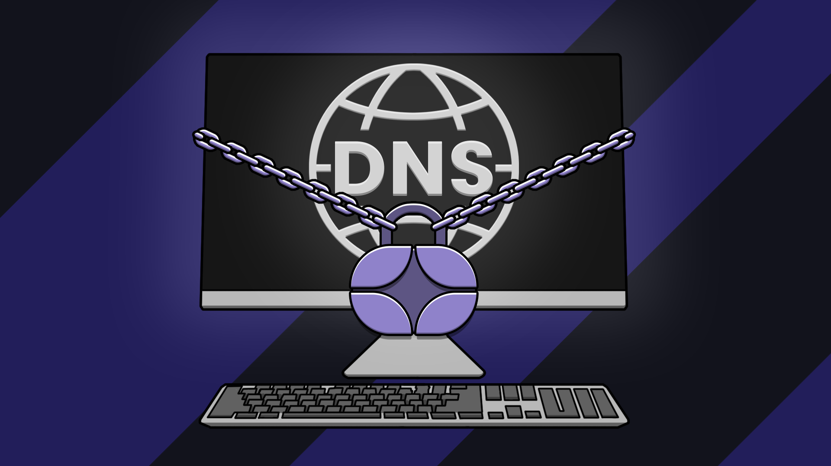

# **1. Introduction**

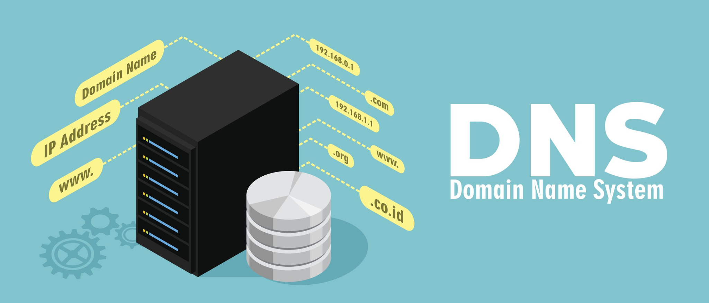

ViewDNS offers a variety of DNS and network tools such as Reverse IP Lookup, DNS Record Lookup, and Whois Lookup. This challenge will introduce you to using ViewDNS to gather detailed DNS information about a target domain.

# **2. Tools and Requirements**

Access to the internet and ViewDNS

# **3. Scenario**

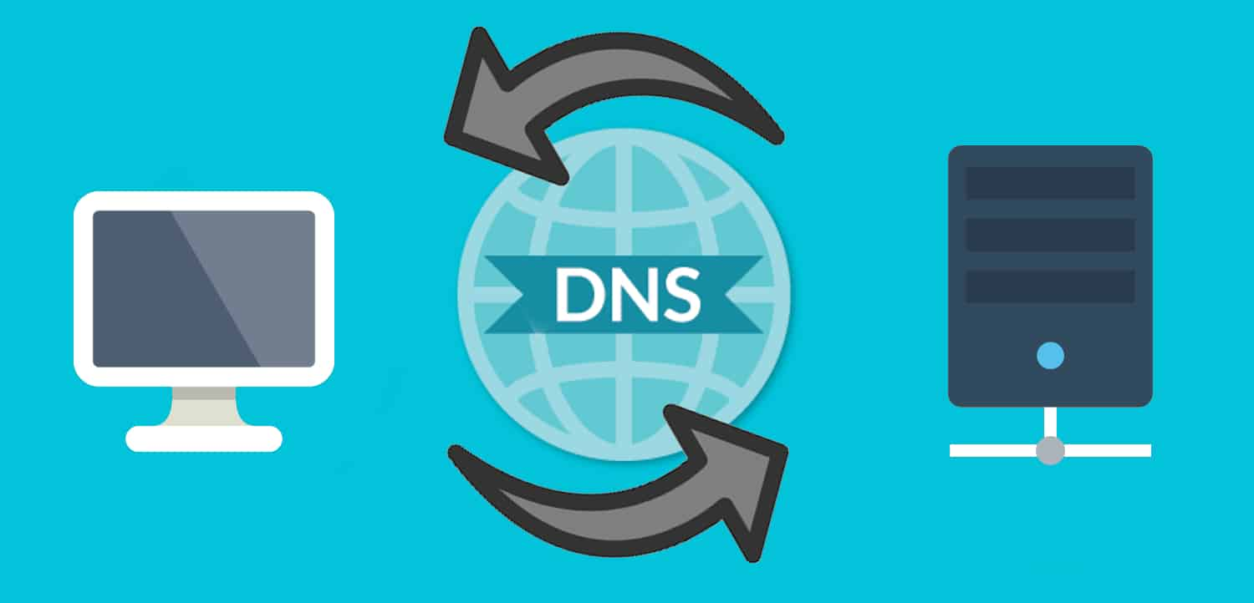

You are a network engineer responsible for ensuring the reliability and security of your company's DNS infrastructure. Your task is to use UsingDNS to analyze the DNS configuration.

# **4. Process to follow while performing CTF**

1. Visit ViewDNS [**https://viewdns.info/**](https://viewdns.info/)

2.Go to ViewDNS.

3.DNS Record Lookup:Enter the URL [**www.facebook.com**](http://www.facebook.com) of the target domain and start the lookup.

4. Go to Reverse MX Lookup and type url [www.facebook.com](http://www.facebook.com)

5. Go to Port Scanner and type url [www.facebook.com](http://www.facebook.com)

# **5. Let’s Begin the Challenge**

**Question**

Flag 1: Which two domains are using this mail server?

Answer: cafebiomaya.com, fiech.org

Flag Captured

Flag 2: What is the status of port 21?

Answer: Closed

Flag Captured

Flag3: How many ports are open?

Answer: 2

Flag Captured

**Hint**

Use the "DNS Recon" tool on DNS Dumpster to perform the analysis.

